Photos of vaccination activities
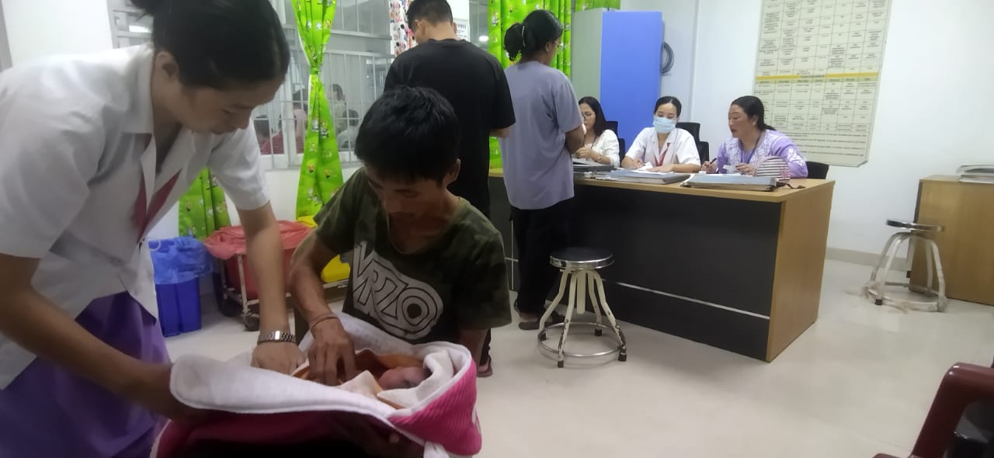

RI Session at TRIMS Itanagar

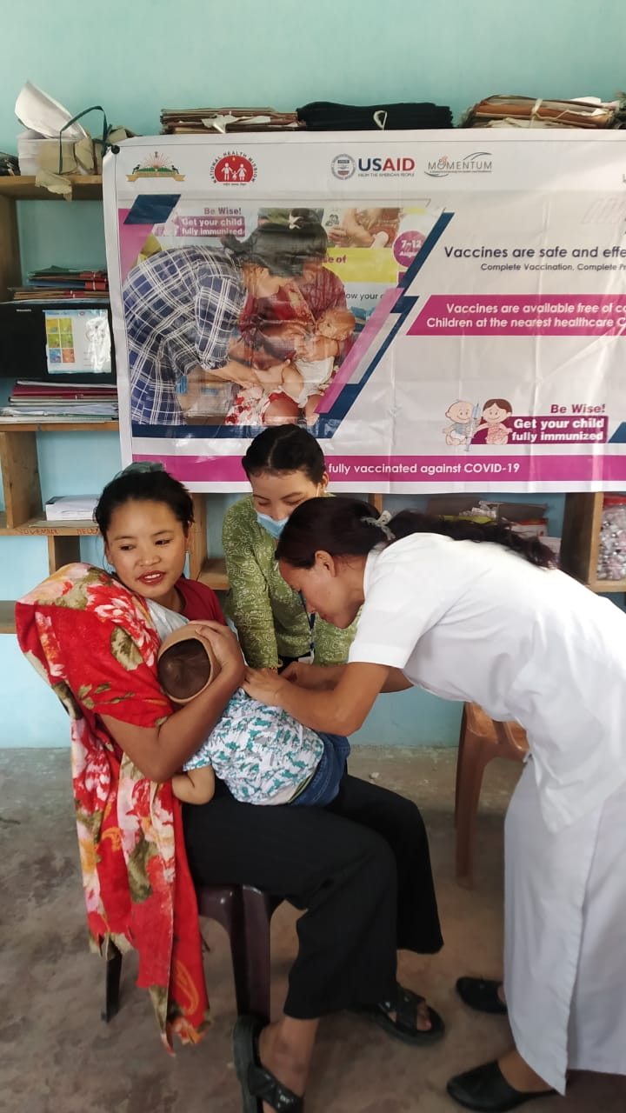
ORS session at DMO office, Palin, Kra Daadi

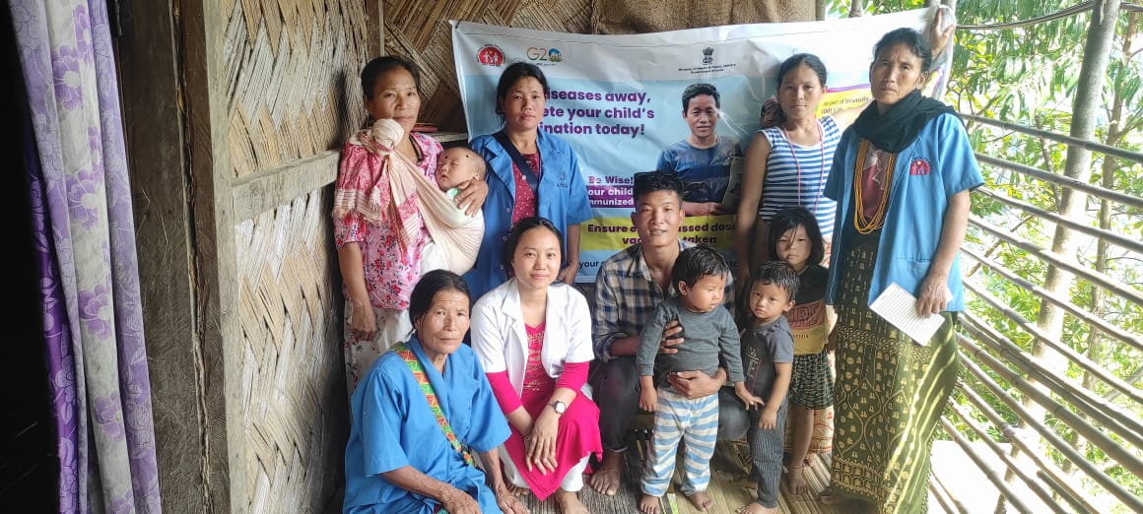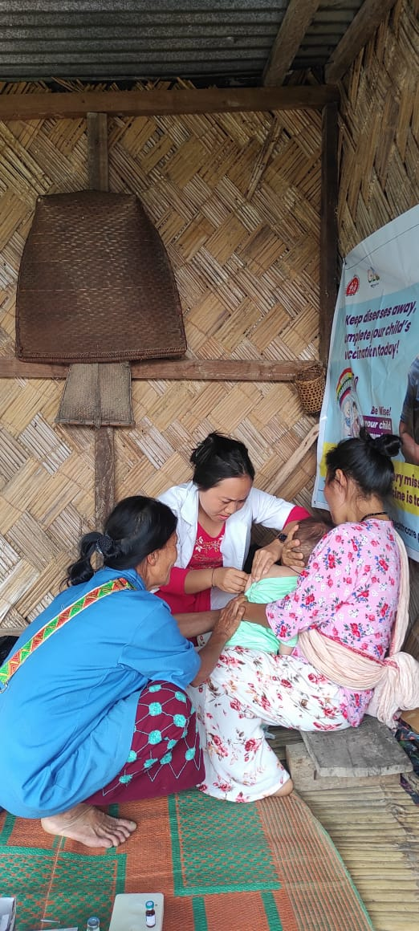
vaccination campaign held at Leel under sub centre, Leel, Sangram, Kurung Kumey

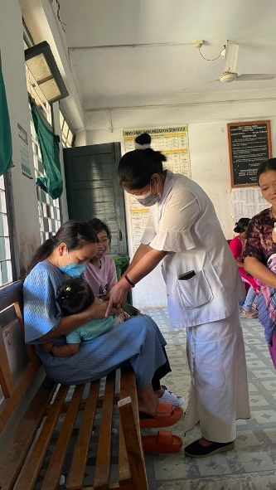
RI session at DH Daporijo, Upper Subansiri

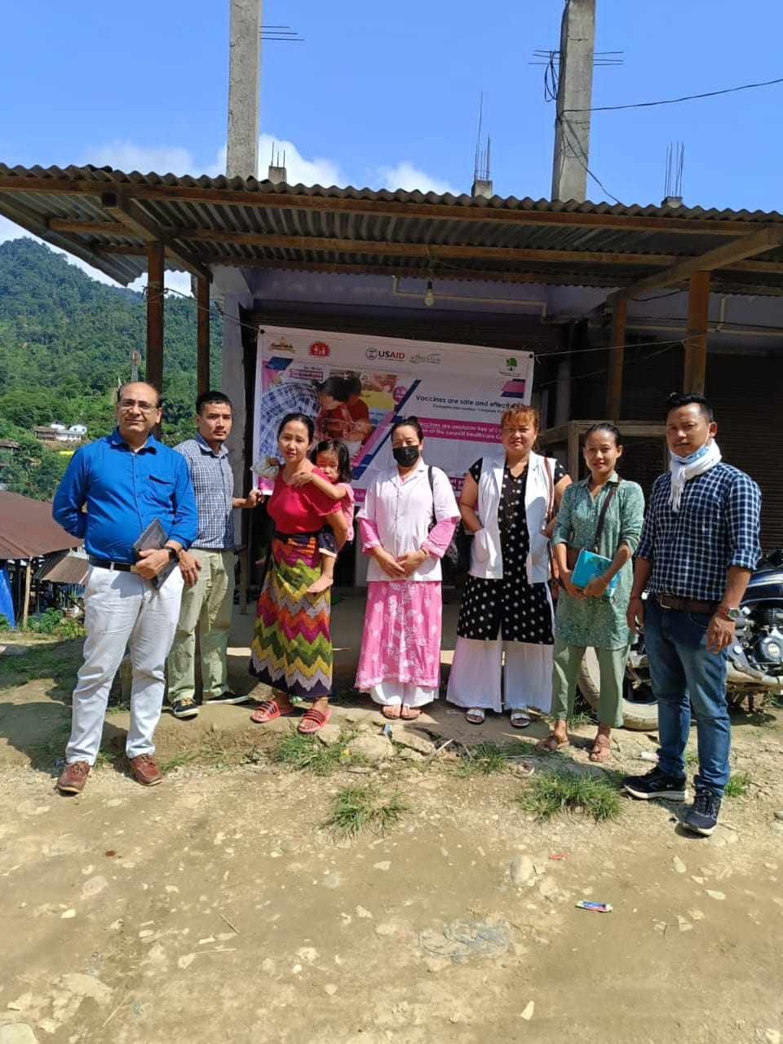
IMI SESSION AND HOUSE' TO HOUSE VISIT AT Bridge point to Sikarijo (Daporijo) upper subansiri

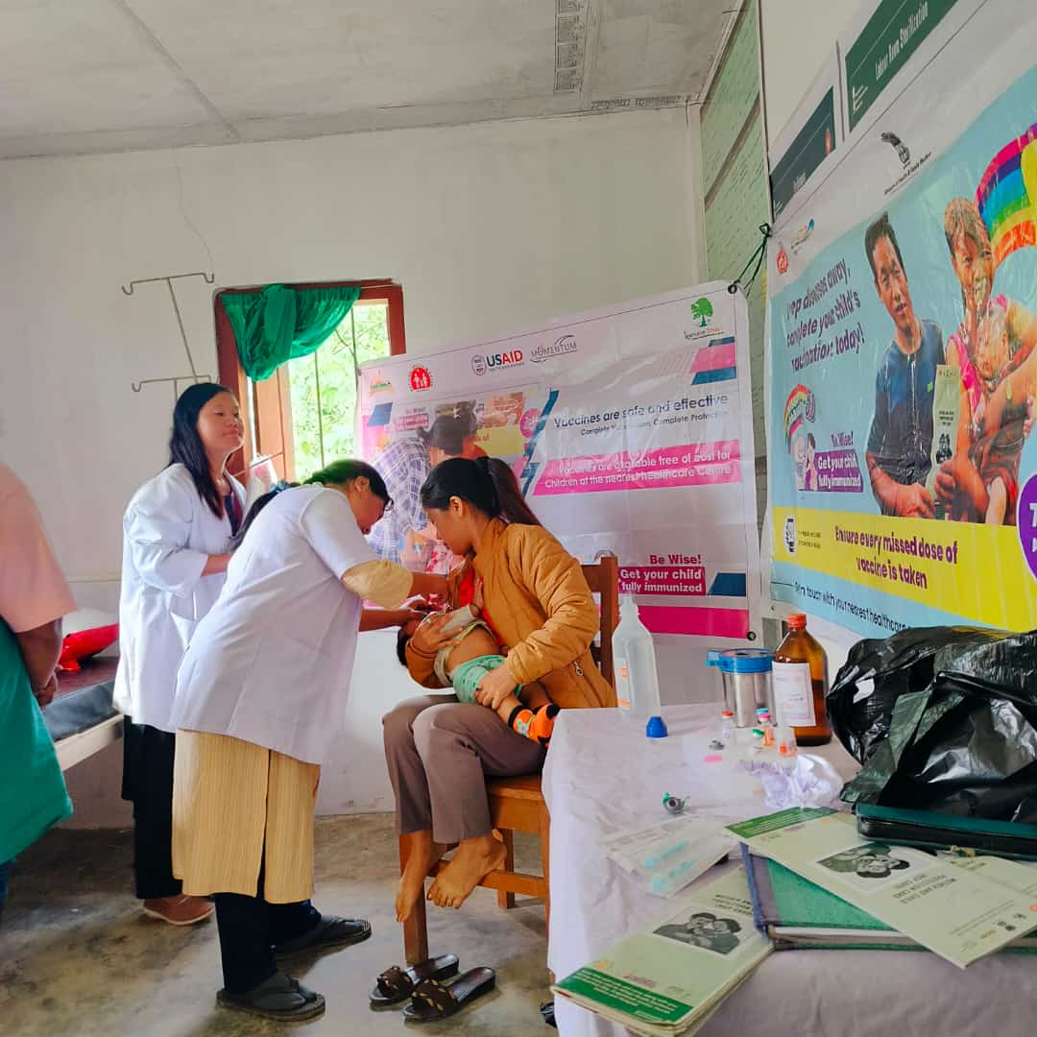
Vaccination at Dado sub centre under yangte block, Kra Daadi

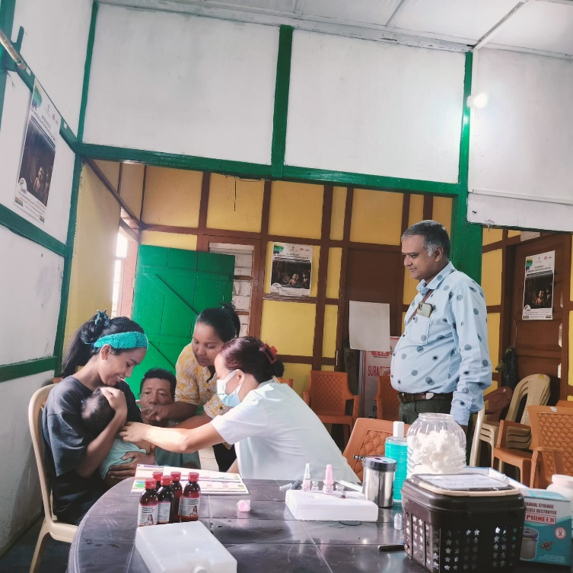
RI session conducted at Out reached area at Palin

IMI at Hong Village by team Lower Subansiri

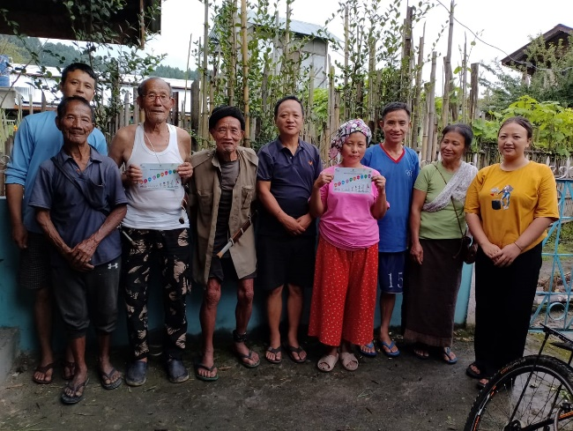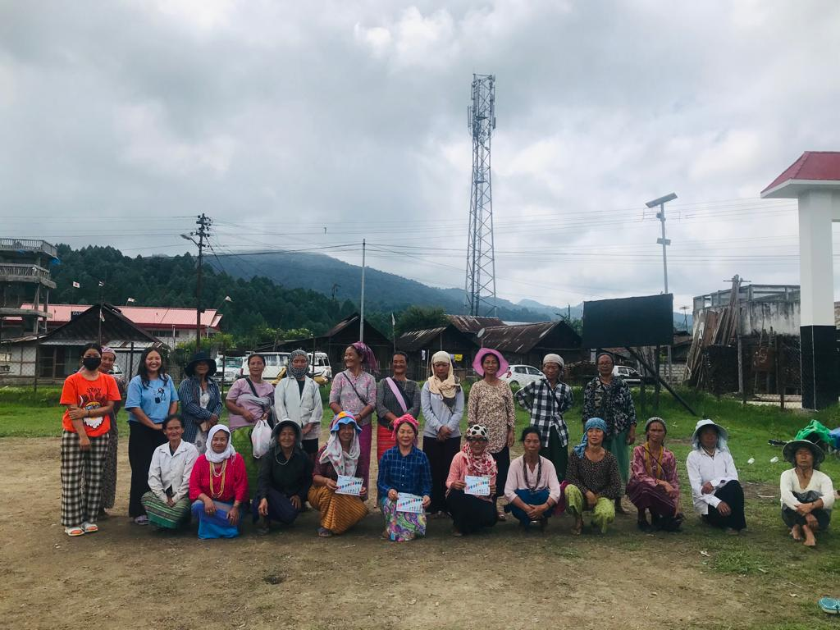
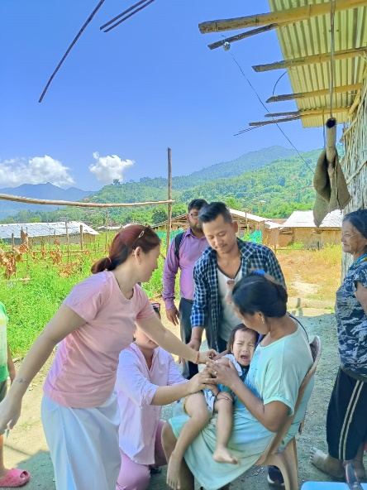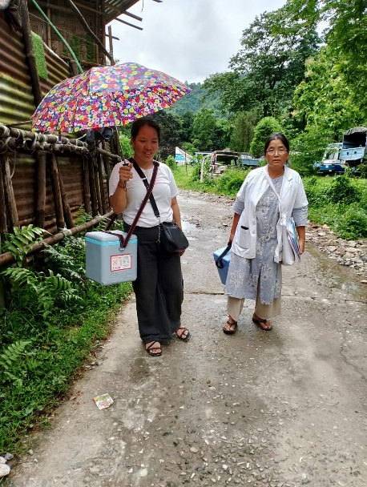
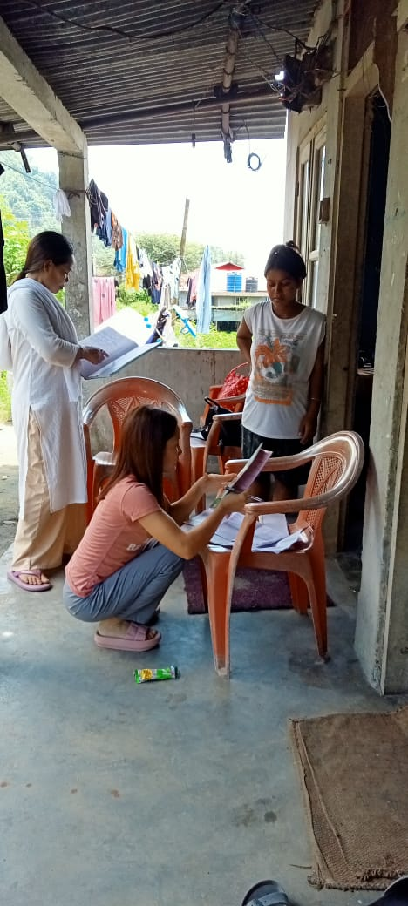
Door to door visit for line listing at Tayeng Tarang village under Doimukh CHC

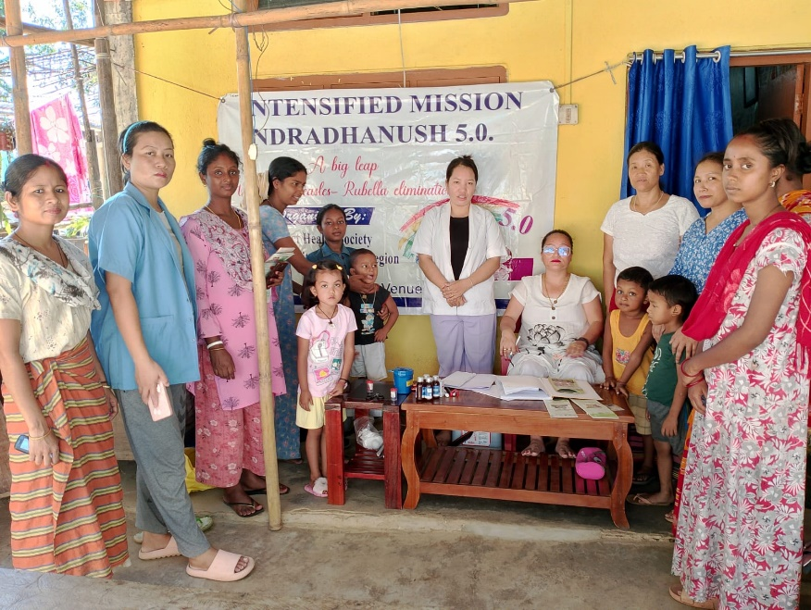
IMI 5.0 conducted at division 4 total beneficiary 12, total vaccinated 4, with the help of staff nurse, Asha and anganwadi worker

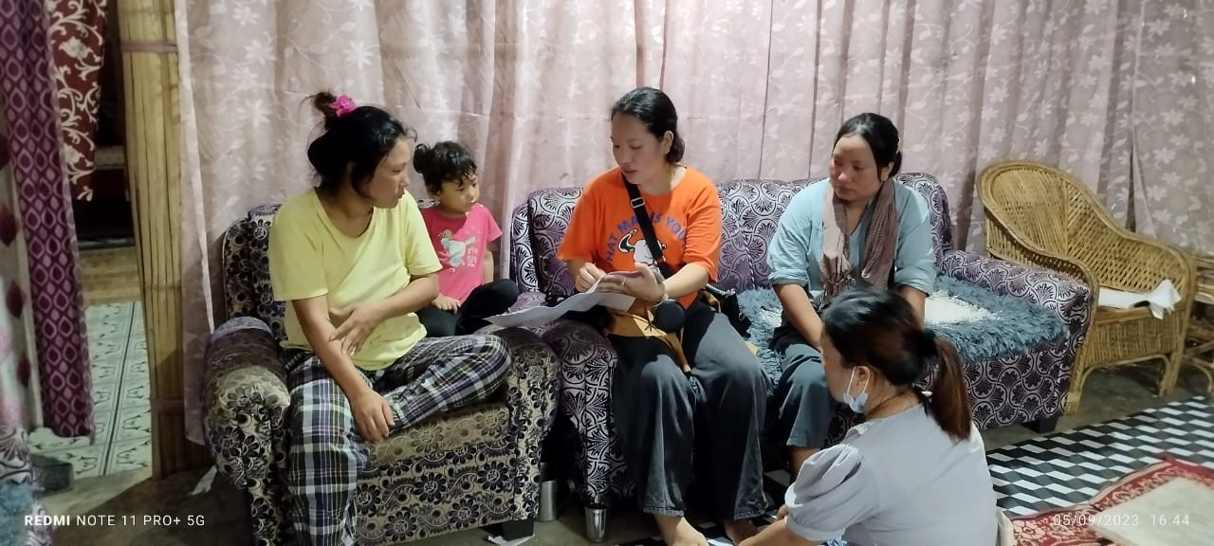
counseling refusal parent to tell about vaccine preventable disease and awareness of IMI 5.0 after our counseling parents agreed to take vaccine at sangay laden

